Assignment – 5
U1527407
Zaid Asif Basri
Part 1: Multi-Field Visualization
Following are the steps I used to get the below results
First I loaded the dataset and applied volume rendering to it for Q Cloud. I have applied “resample to image” filter to the main dataset and got the below results.
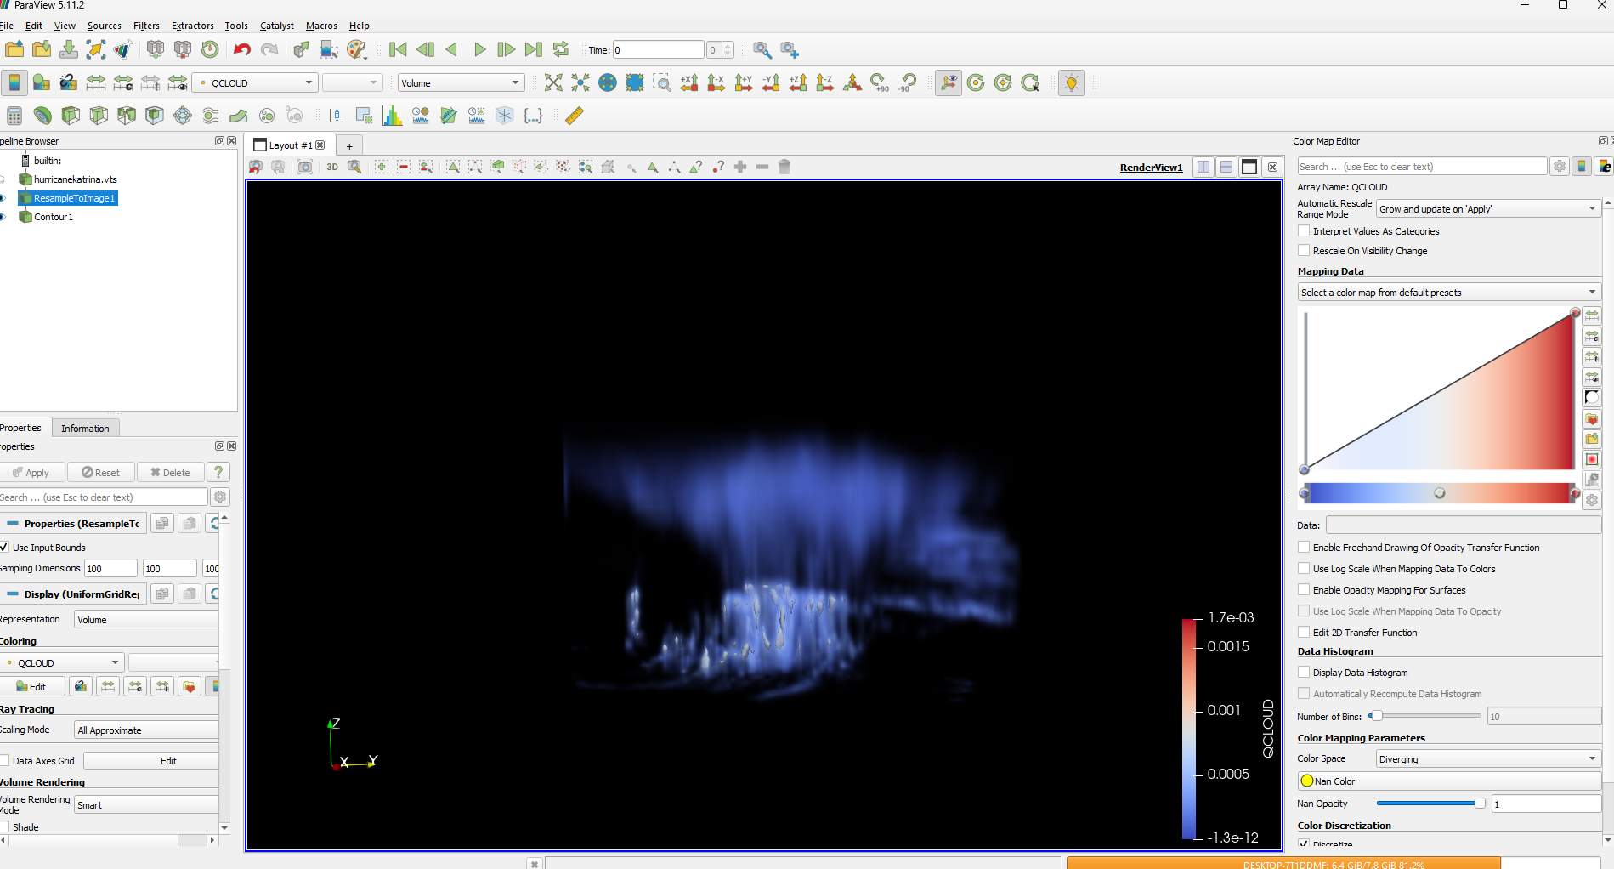
Fig 1: Output after volume rendering

Next I’ve applied the contour filter in order to produce the iso-surface visualization. I’ve kept the isosurface value around 0.0003098, I have applied solid color for displaying the contours. Below is the result achieved.
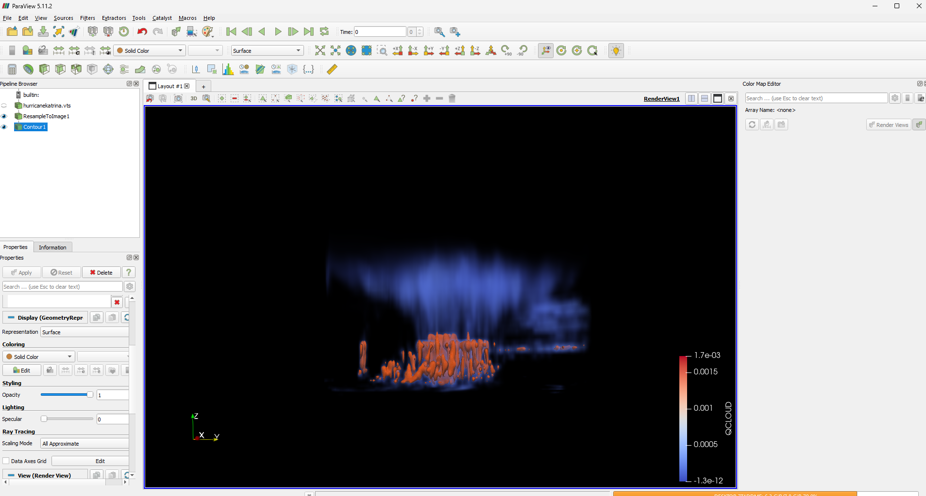
Fig 2: Output after Iso-contour filter

Note:
My personal system crashed here after I applied stream tracer and glyph, hence I had to change the system to college laptop hence the screenshots will look different.

I have next applied stream tracer filter to get the streamlines of the wind flow. I placed the seed line diagonally across the hurricane. I modified the color and also reduced the resolution map to get better understanding. Below is the achieved output.
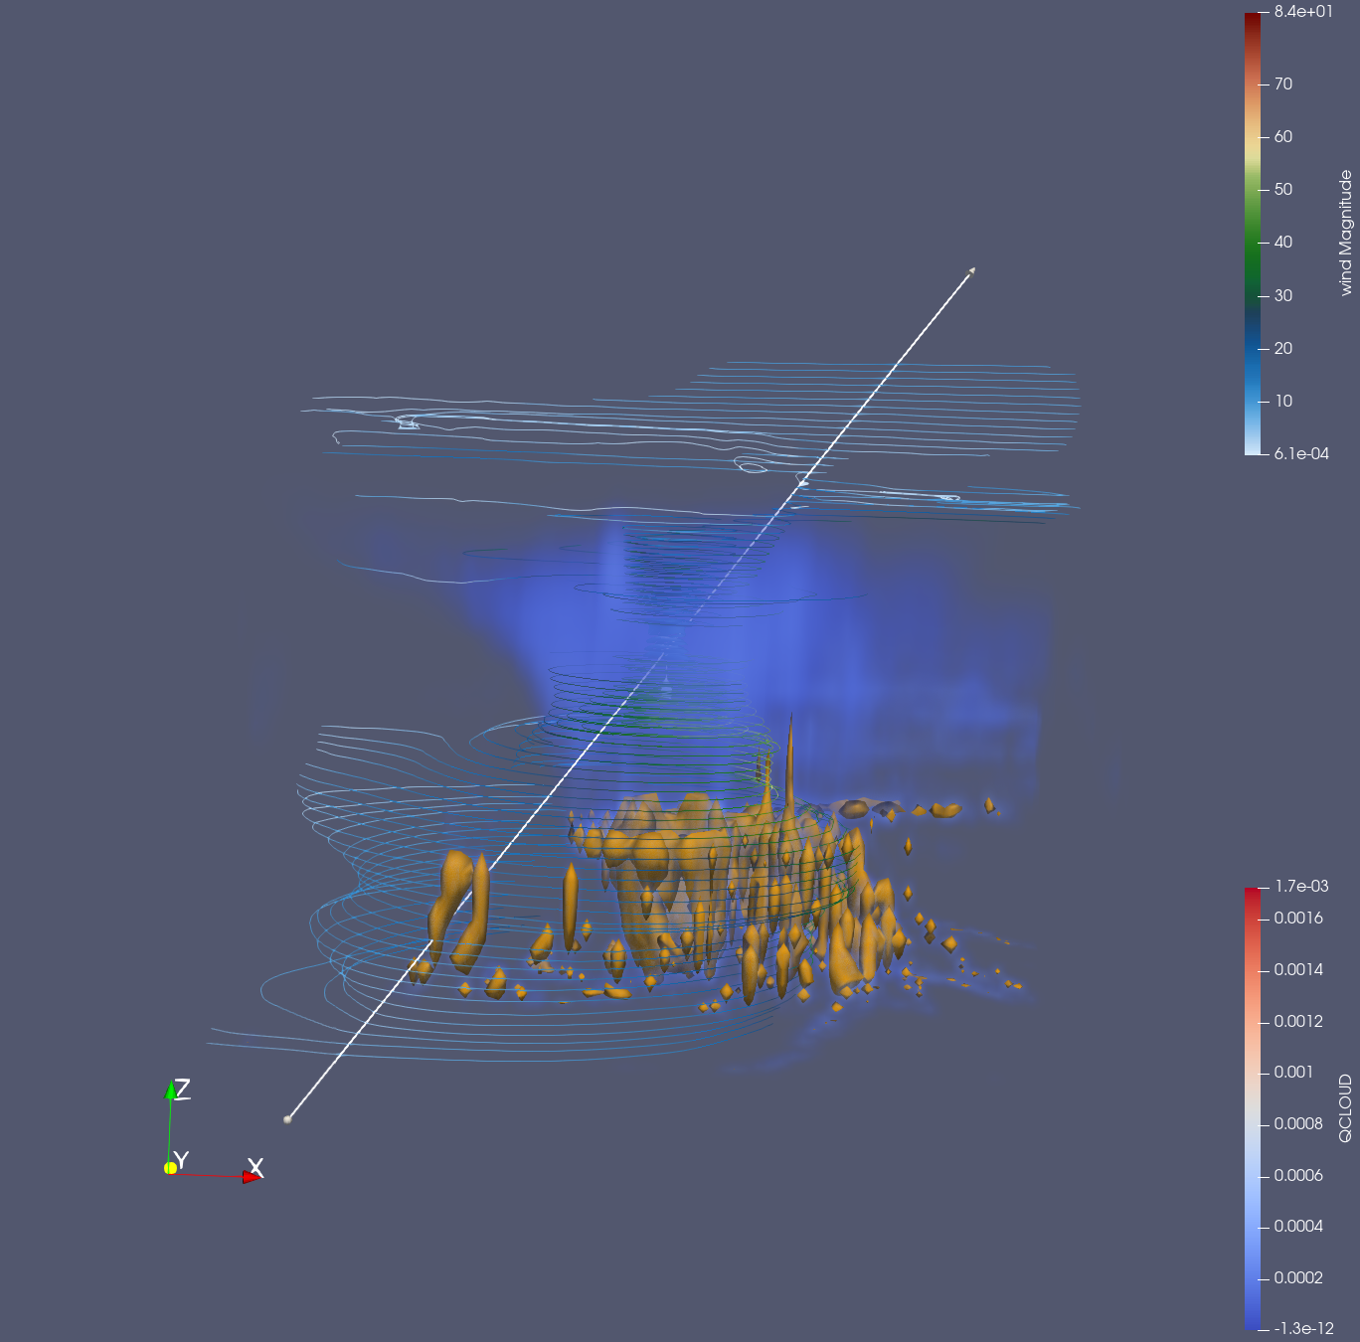
Fig 3: Output after Stream Lines filter

Finally we applied the glyph filter to get the arrows on the streamlines. We can clearly see the wind direction. I also modified the scale factor and number of sample points to get better results. We can see the final output below.
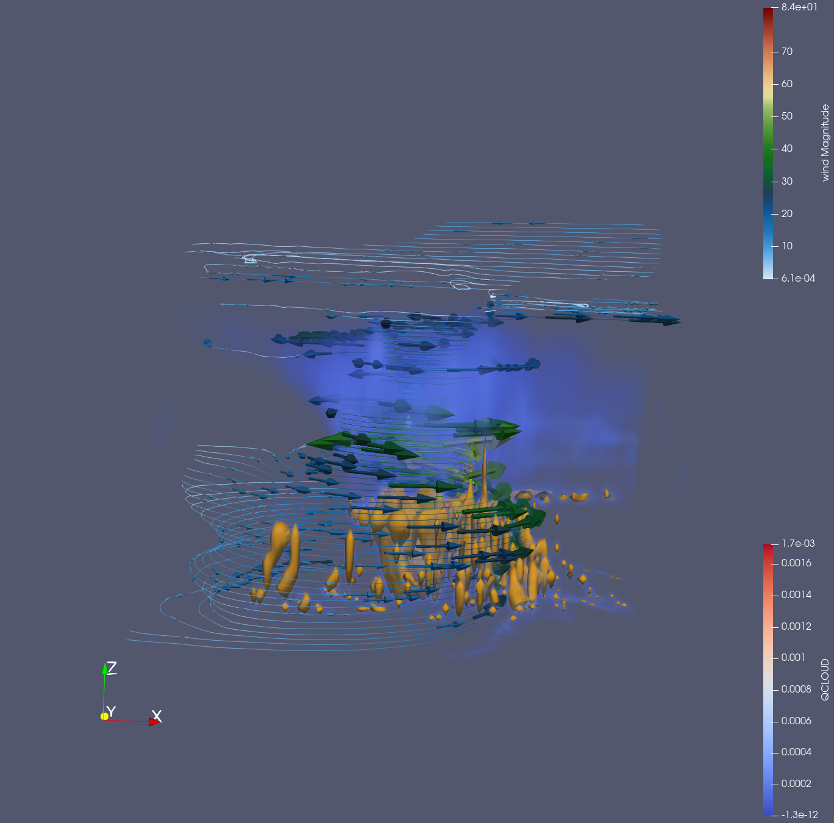
Fig 4: Final output with glyph arrows

Part 2:
1) What is diffusion tensor MRI imaging?
Diffusion Tensor Magnetic Resonance Imaging (DT-MRI) is a medical imaging technique used to measure the diffusion of water molecules in biological tissues, particularly in the brain. It helps visualize the structure of white matter by tracking the direction and rate of water diffusion, which tends to follow nerve fiber paths.
Three types of diffusivities:
- Axial Diffusivity (AD):
Measures diffusion along the main axis of the tensor (i.e., the principal direction of diffusion, typically aligned with nerve fibers). It reflects the integrity of axons.
- Radial Diffusivity (RD):
Measures diffusion perpendicular to the main axis. It’s used to assess myelin sheath integrity higher values may indicate demyelination.
- Mean Diffusivity (MD):
The average of diffusion in all directions. It provides a general sense of how freely water molecules move within tissue.
Mathematical Representation:
A diffusion tensor is a 3x3 symmetric positive-definite matrix:
D = [ Dxx Dxy Dxz
Dxy Dyy Dyz
Dxz Dyz Dzz ]
This tensor captures the 3D diffusion properties of water in tissue.
The diffusion tensor in case of fractional anisotropy can be represented as the sum of linear, planar and spherical diffusion
Therefore Cl + Cp + Cs = 1

2) Glyph-based Visualization of Tensor Fields
Box Glyphs:
- Description: Represent tensors using axis-aligned boxes whose shape and orientation reflect eigenvectors and eigenvalues.
- Pros: Simple, fast to render.
- Cons: Limited visual expressiveness; less intuitive for complex diffusion patterns.
Ellipsoid Glyphs:
- Description: Use ellipsoids where the principal axes align with the tensor's eigenvectors, and their lengths scale with eigenvalues.
- Pros: Intuitive; visually shows anisotropy and direction.
- Cons: Can look similar for different tensors; harder to interpret in cluttered areas.
Superquadric Glyphs:
- Description: Generalizations of ellipsoids that can represent a wider range of tensor shapes by adjusting shape parameters.
- Pros: More expressive; can differentiate between linear, planar, and isotropic tensors.
- Cons: Computationally more complex, harder to interpret without experience.

Advantages:
By translating the eigenvectors and eigenvalues of a tensor into geometric orientation and shape, one can gain meaningful insights into the underlying tensor variables. Tensor fields are often visualized using geometric primitives like cuboids and ellipsoids, which serve as intuitive representations of direction and magnitude. Superquadric glyphs, while more flexible in form, share visual similarities with ellipsoids and can be adapted to capture more complex field variations. These glyphs not only encode tensor information visually but also enhance spatial understanding of field behavior. Additionally, interactive manipulation of glyphs such as scaling or rotating them can further assist in identifying subtle patterns or anomalies in the tensor data.
Disadvantages:
Glyphs can sometimes create visual confusion due to their rotational symmetry. From specific angles, shapes like boxes, cylinders, and ellipsoids may appear similar, leading to misinterpretation of the represented data. Additionally, overly complex or densely packed glyphs can result in visual clutter, making it harder to distinguish patterns or extract meaningful insights.

Part 3:
Step 1:
In this section, I followed all the steps for T1 and T2. In Step 2, I set the diffusion sampling ratio to 0.8. After that, I executed the steps in T3.
Due to the low sampling ratio, we can observe in the T3b area that only one fiber is visible per pixel. The image below shows the axial view of the brain. The fibers indicate the pathways of water diffusion, and the colors represent the type or direction of diffusion.
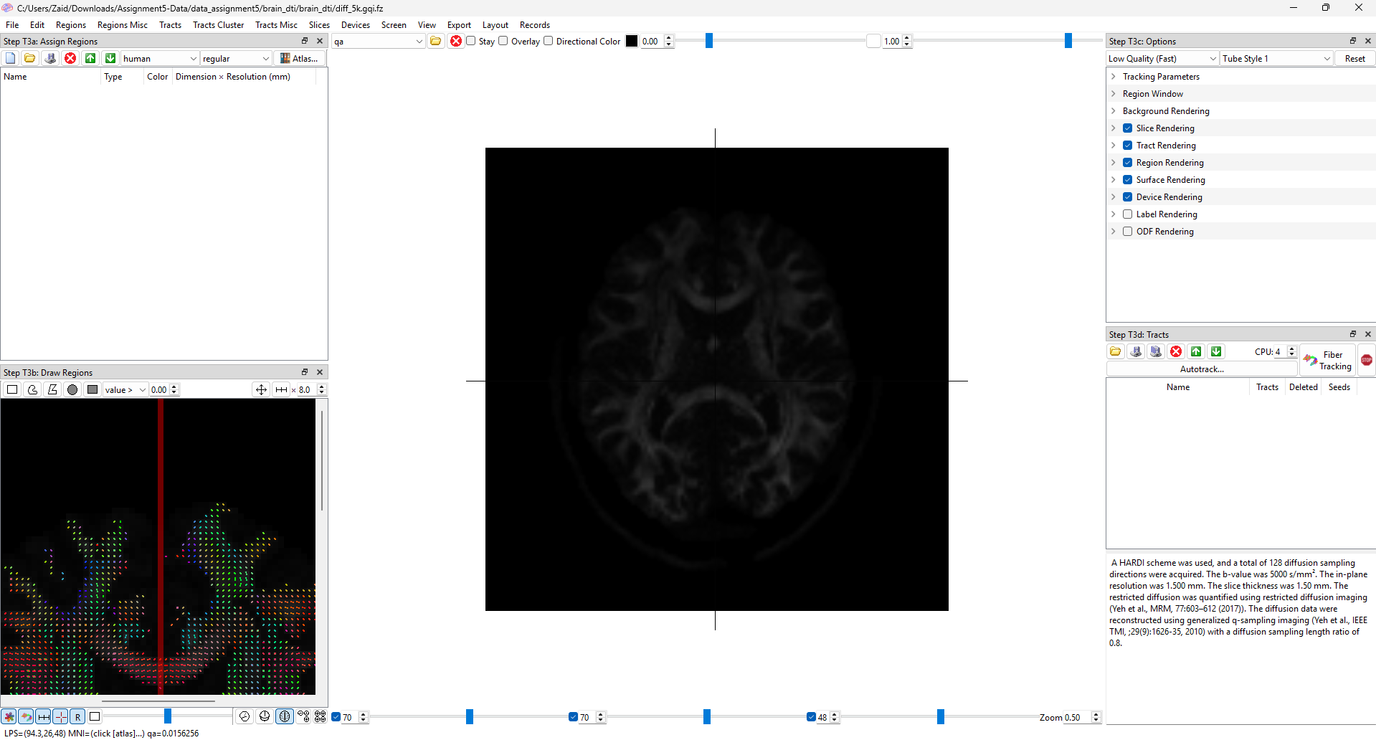
Fig 5: Axial view of the brain
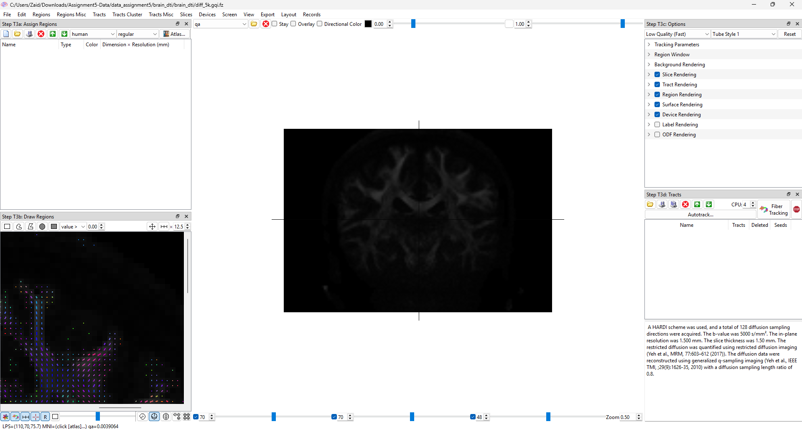
Fig 6: Coronal view of the brain
Step 2:
I have generated the fiber tracking and also changed the T3c parameter to receive the below two results which are in axial and sagittal view.
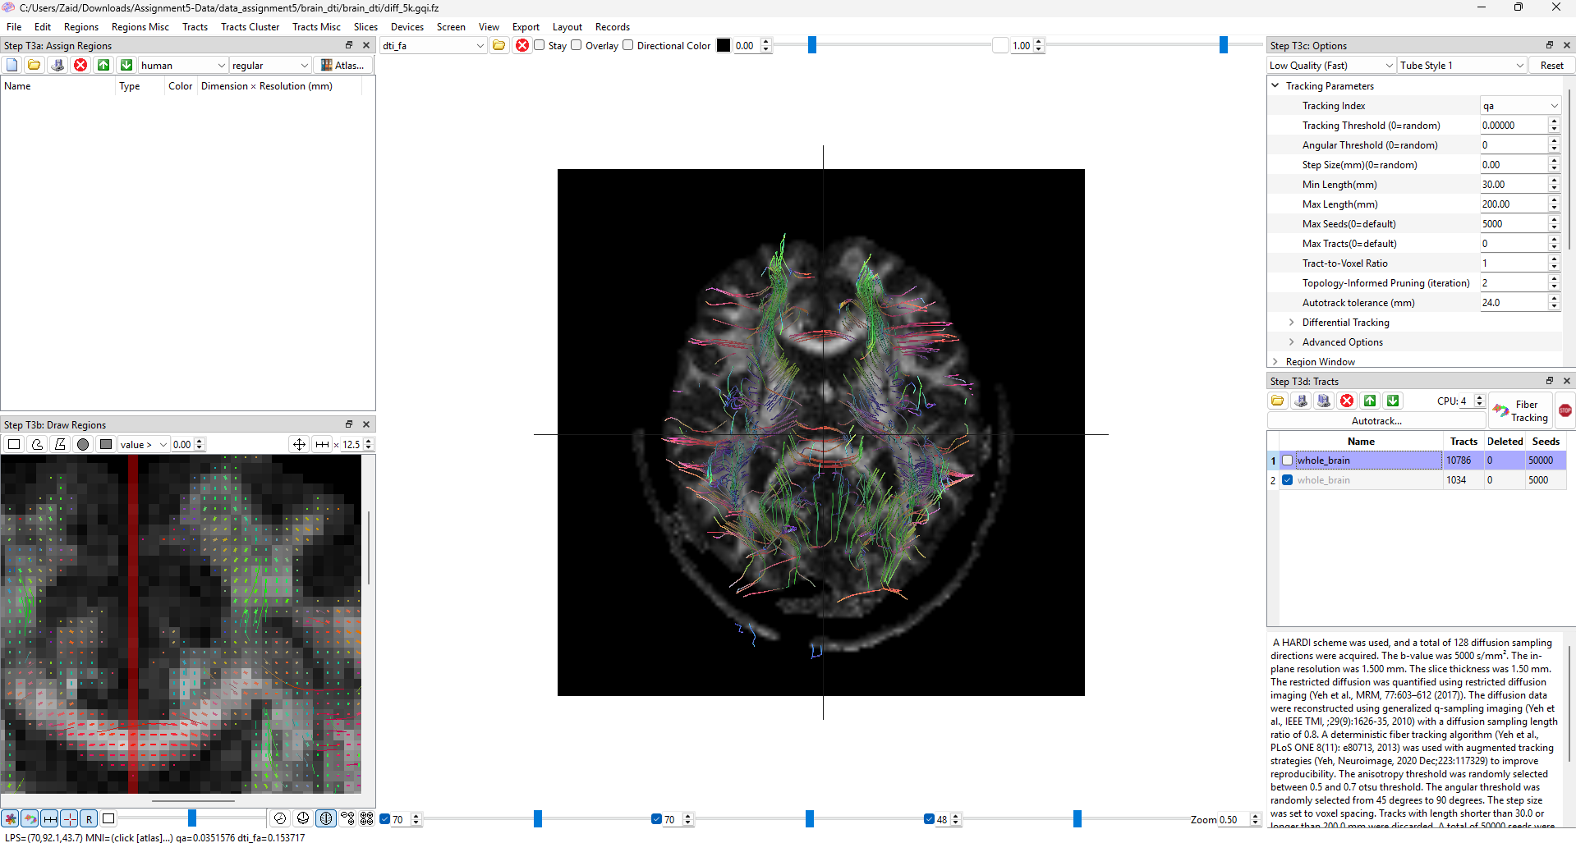
Fig 7: Axial view of the tractography of the brain
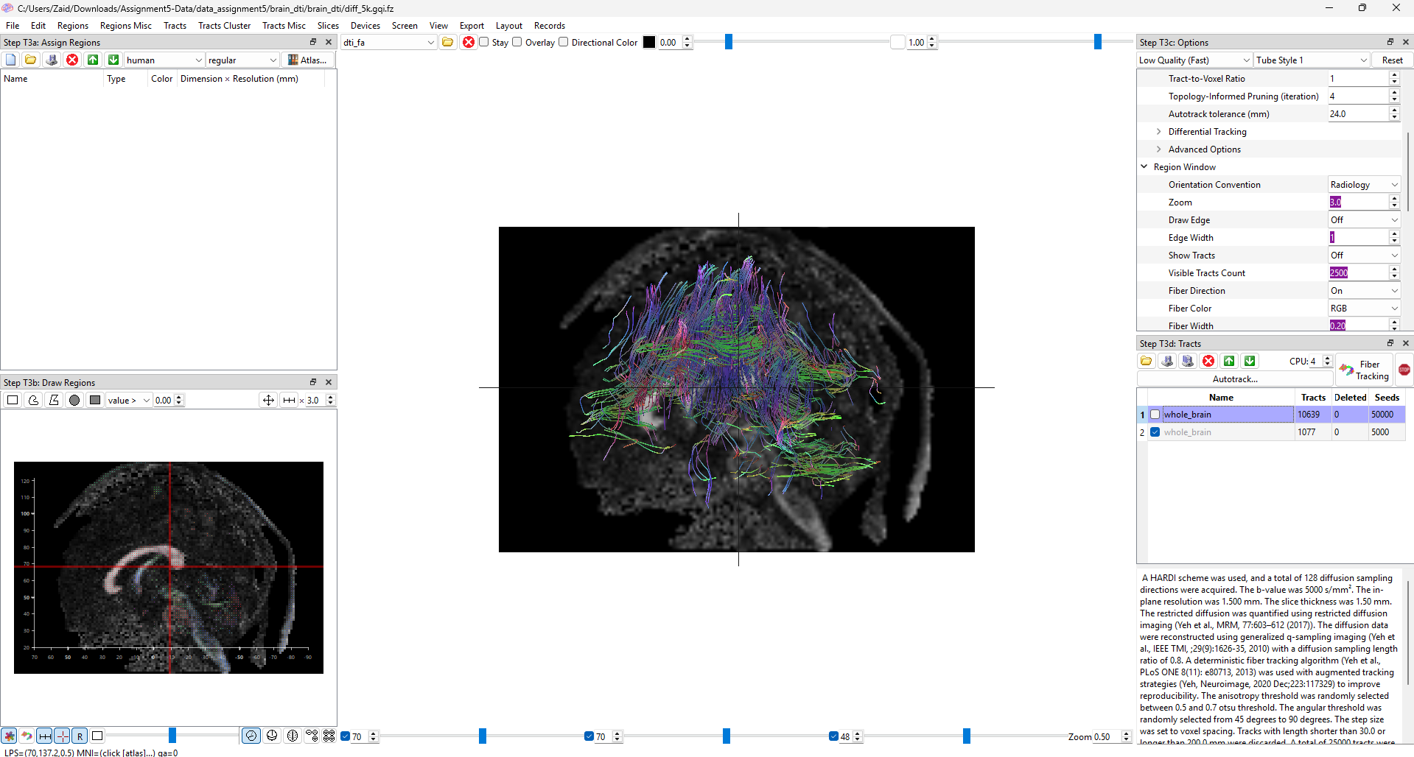
Fig 8: Coronal view of the tractography of the brain
In the images above, the white matter tracts are shown linking various regions of the brain. The fibers illustrate the direction of water diffusion, while the colors indicate its intensity.

Step 3:
In this step, I adjusted parameters such as “Terminate If”, “Minimum Length”, and “Maximum Length” to generate the displayed image. The view has been switched to sagittal, and the slice type is set to dti_fa for improved image clarity. As a result, we can clearly observe the fibers passing through the spinal cord region in the brain.

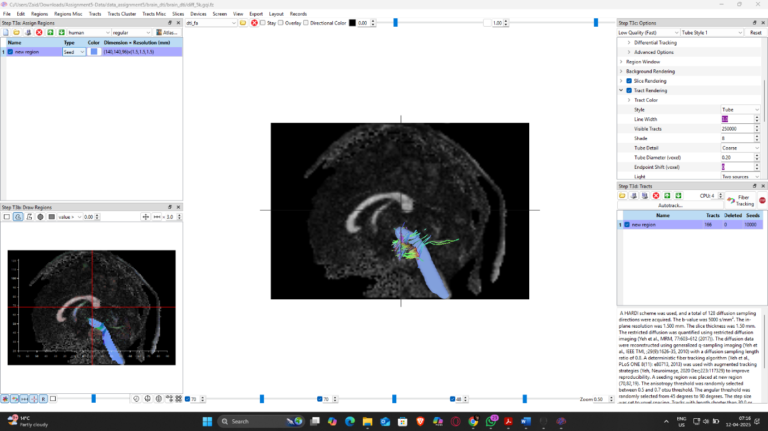
Fig 9: Sagittal view of the tractography near the spinal cord

Step 4:
I used cubic regions to cover each hemisphere of the brain, placing multiple cuboids to fill the space effectively. One of these regions was designated as the seed, while another was selected as the region of interest (ROI). After adjusting the parameters, I was able to visualize the fiber tracts originating from the seed region and passing through the ROI. For some reason despite trying out different parameters I wasn’t able to produce as many tracks as I should’ve in order to achieve better visualization and this was the best I could produce the application also kept crashing at times.

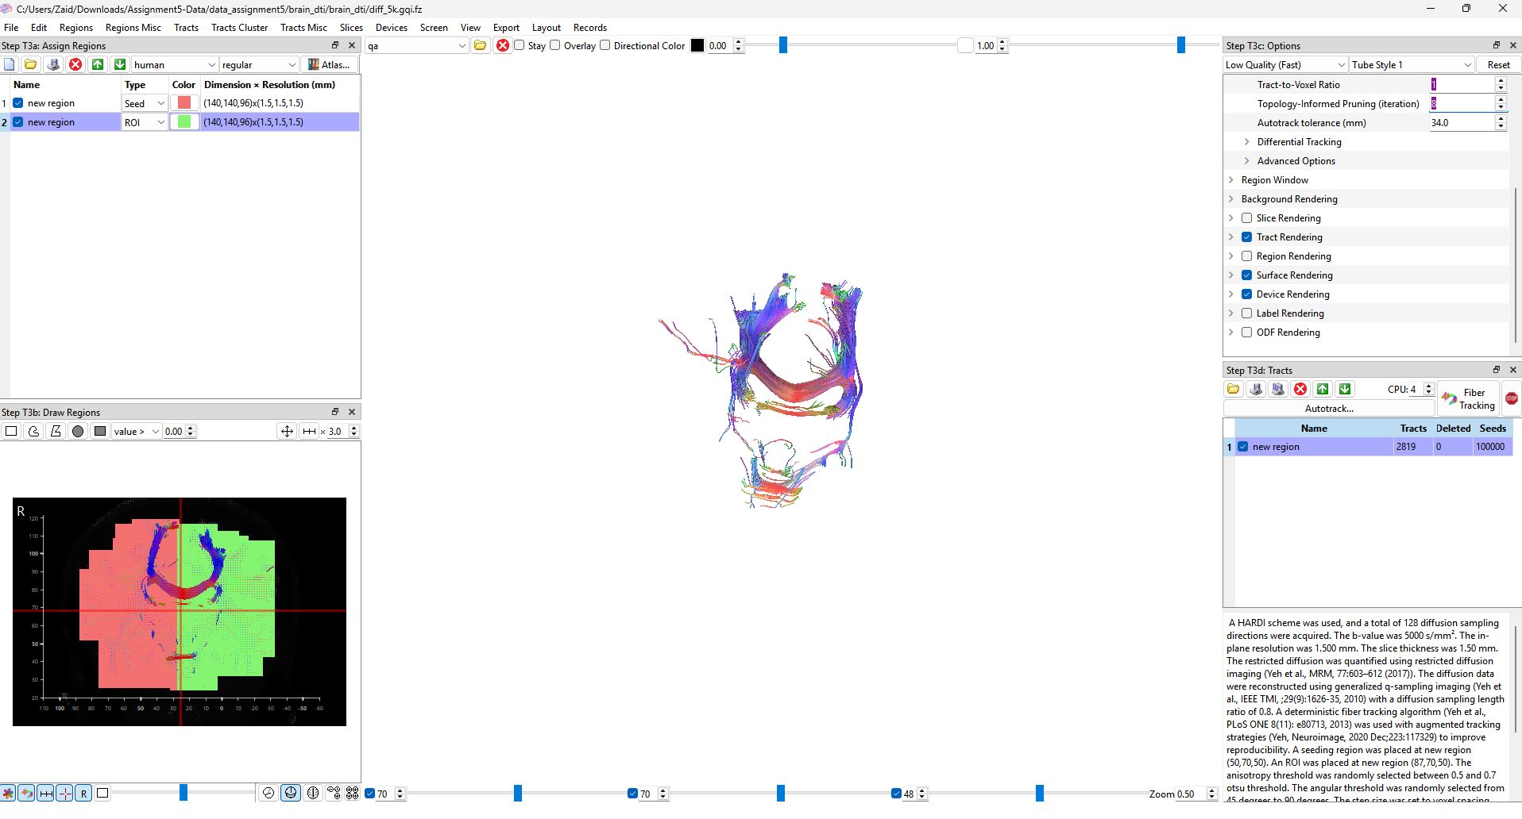
Fig 20: Tractography of two regions of brain

Part 4:
In this part, I have applied tensor glyph filter to the dataset.
- Cylinder:
The below images are the output after applying the cylinder glyph. These are the parameters which I have used height =1, radius = 0.5, center = 0. 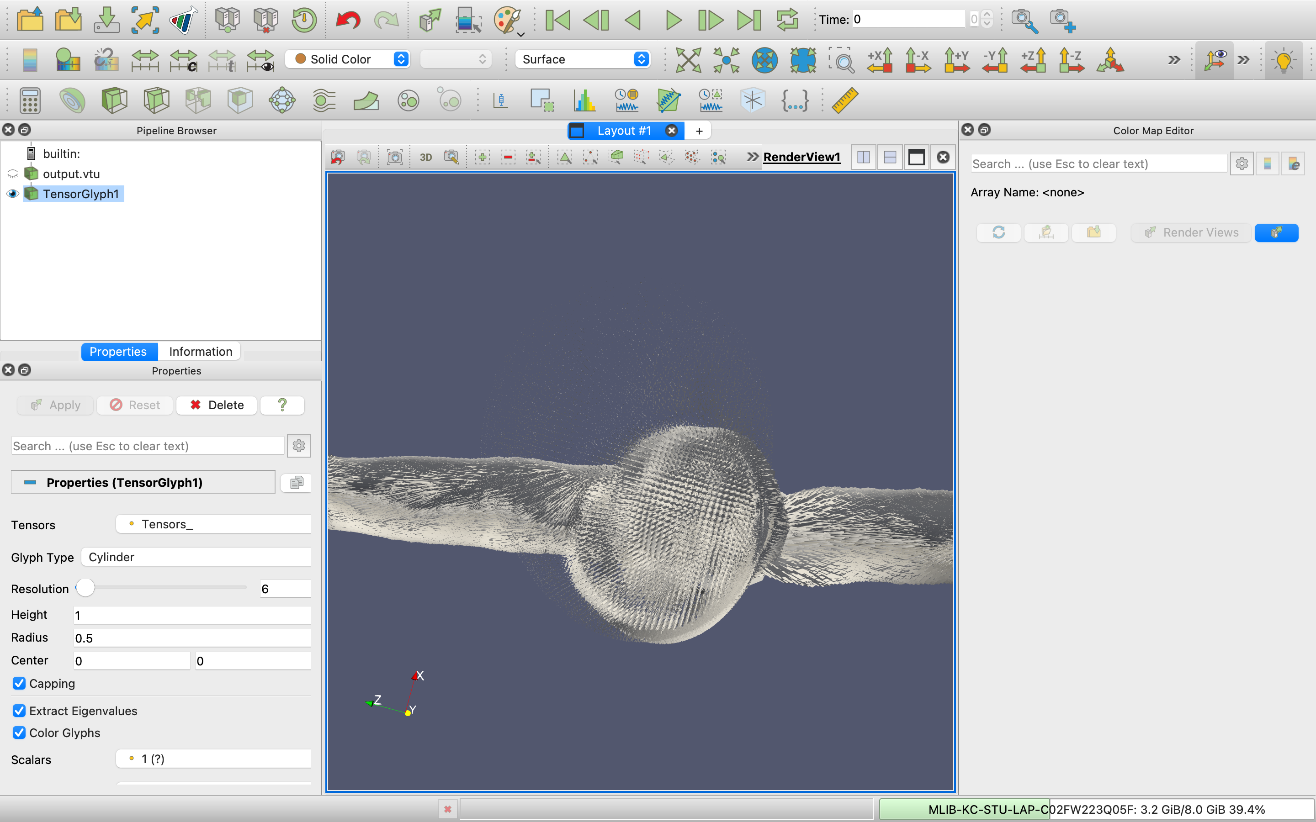
Fig 21: Cylinder glyph from outer region
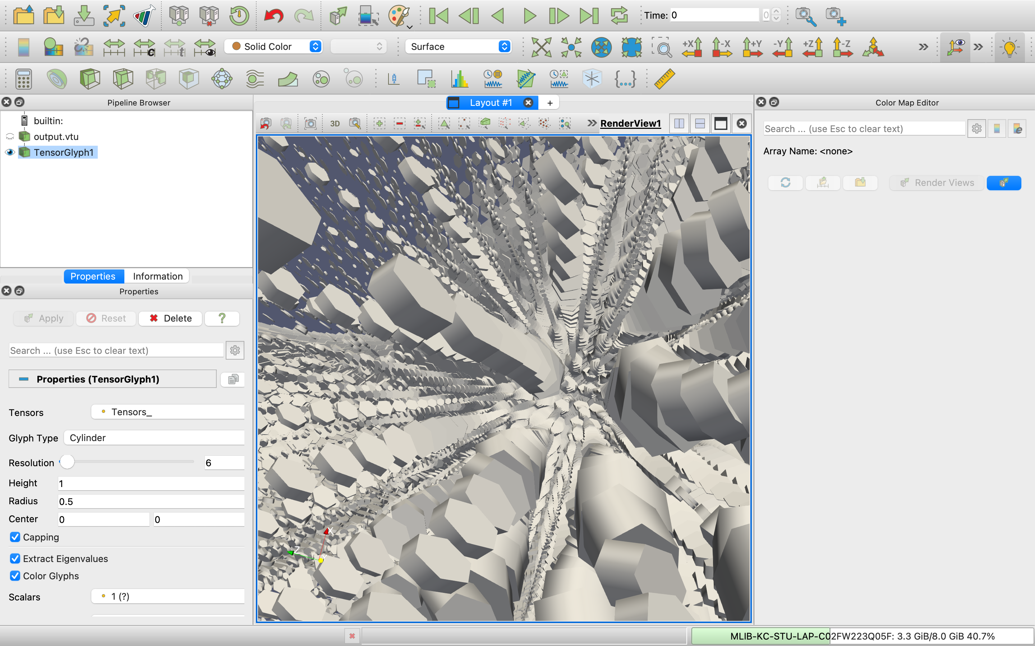
Fig 22: Cylinder glyph closer view
- Sphere:
Below are the output images of sphere glyph with Center = 0, Radius = 0.5, Theta resoln. = 8 and Phi resoln. = 8.
- 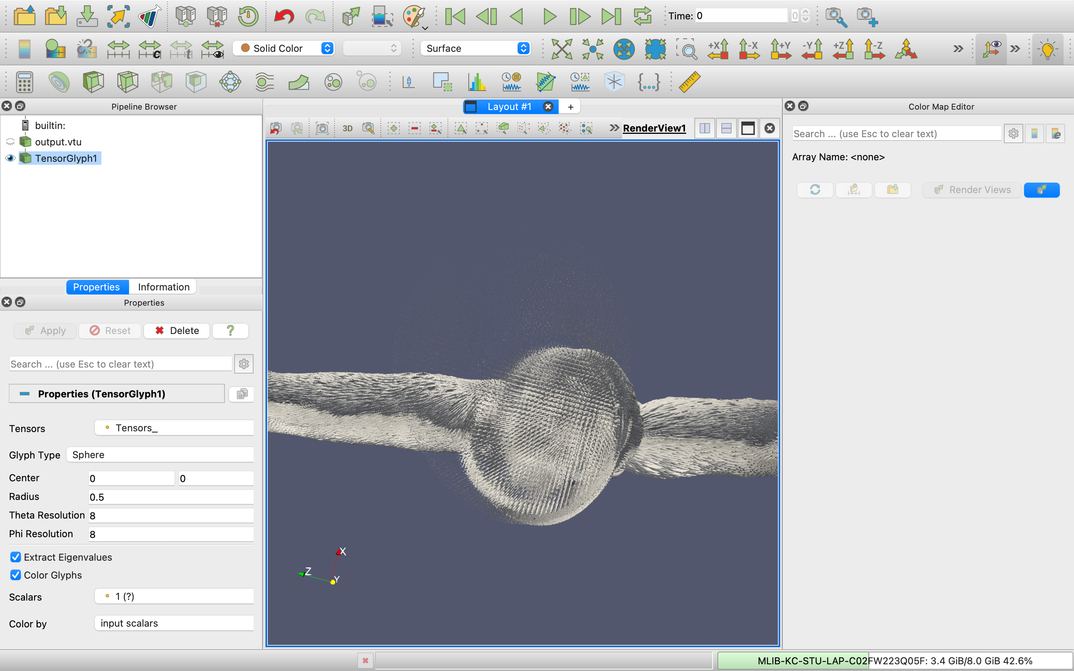
Fig 23: Sphere glyph from outer region
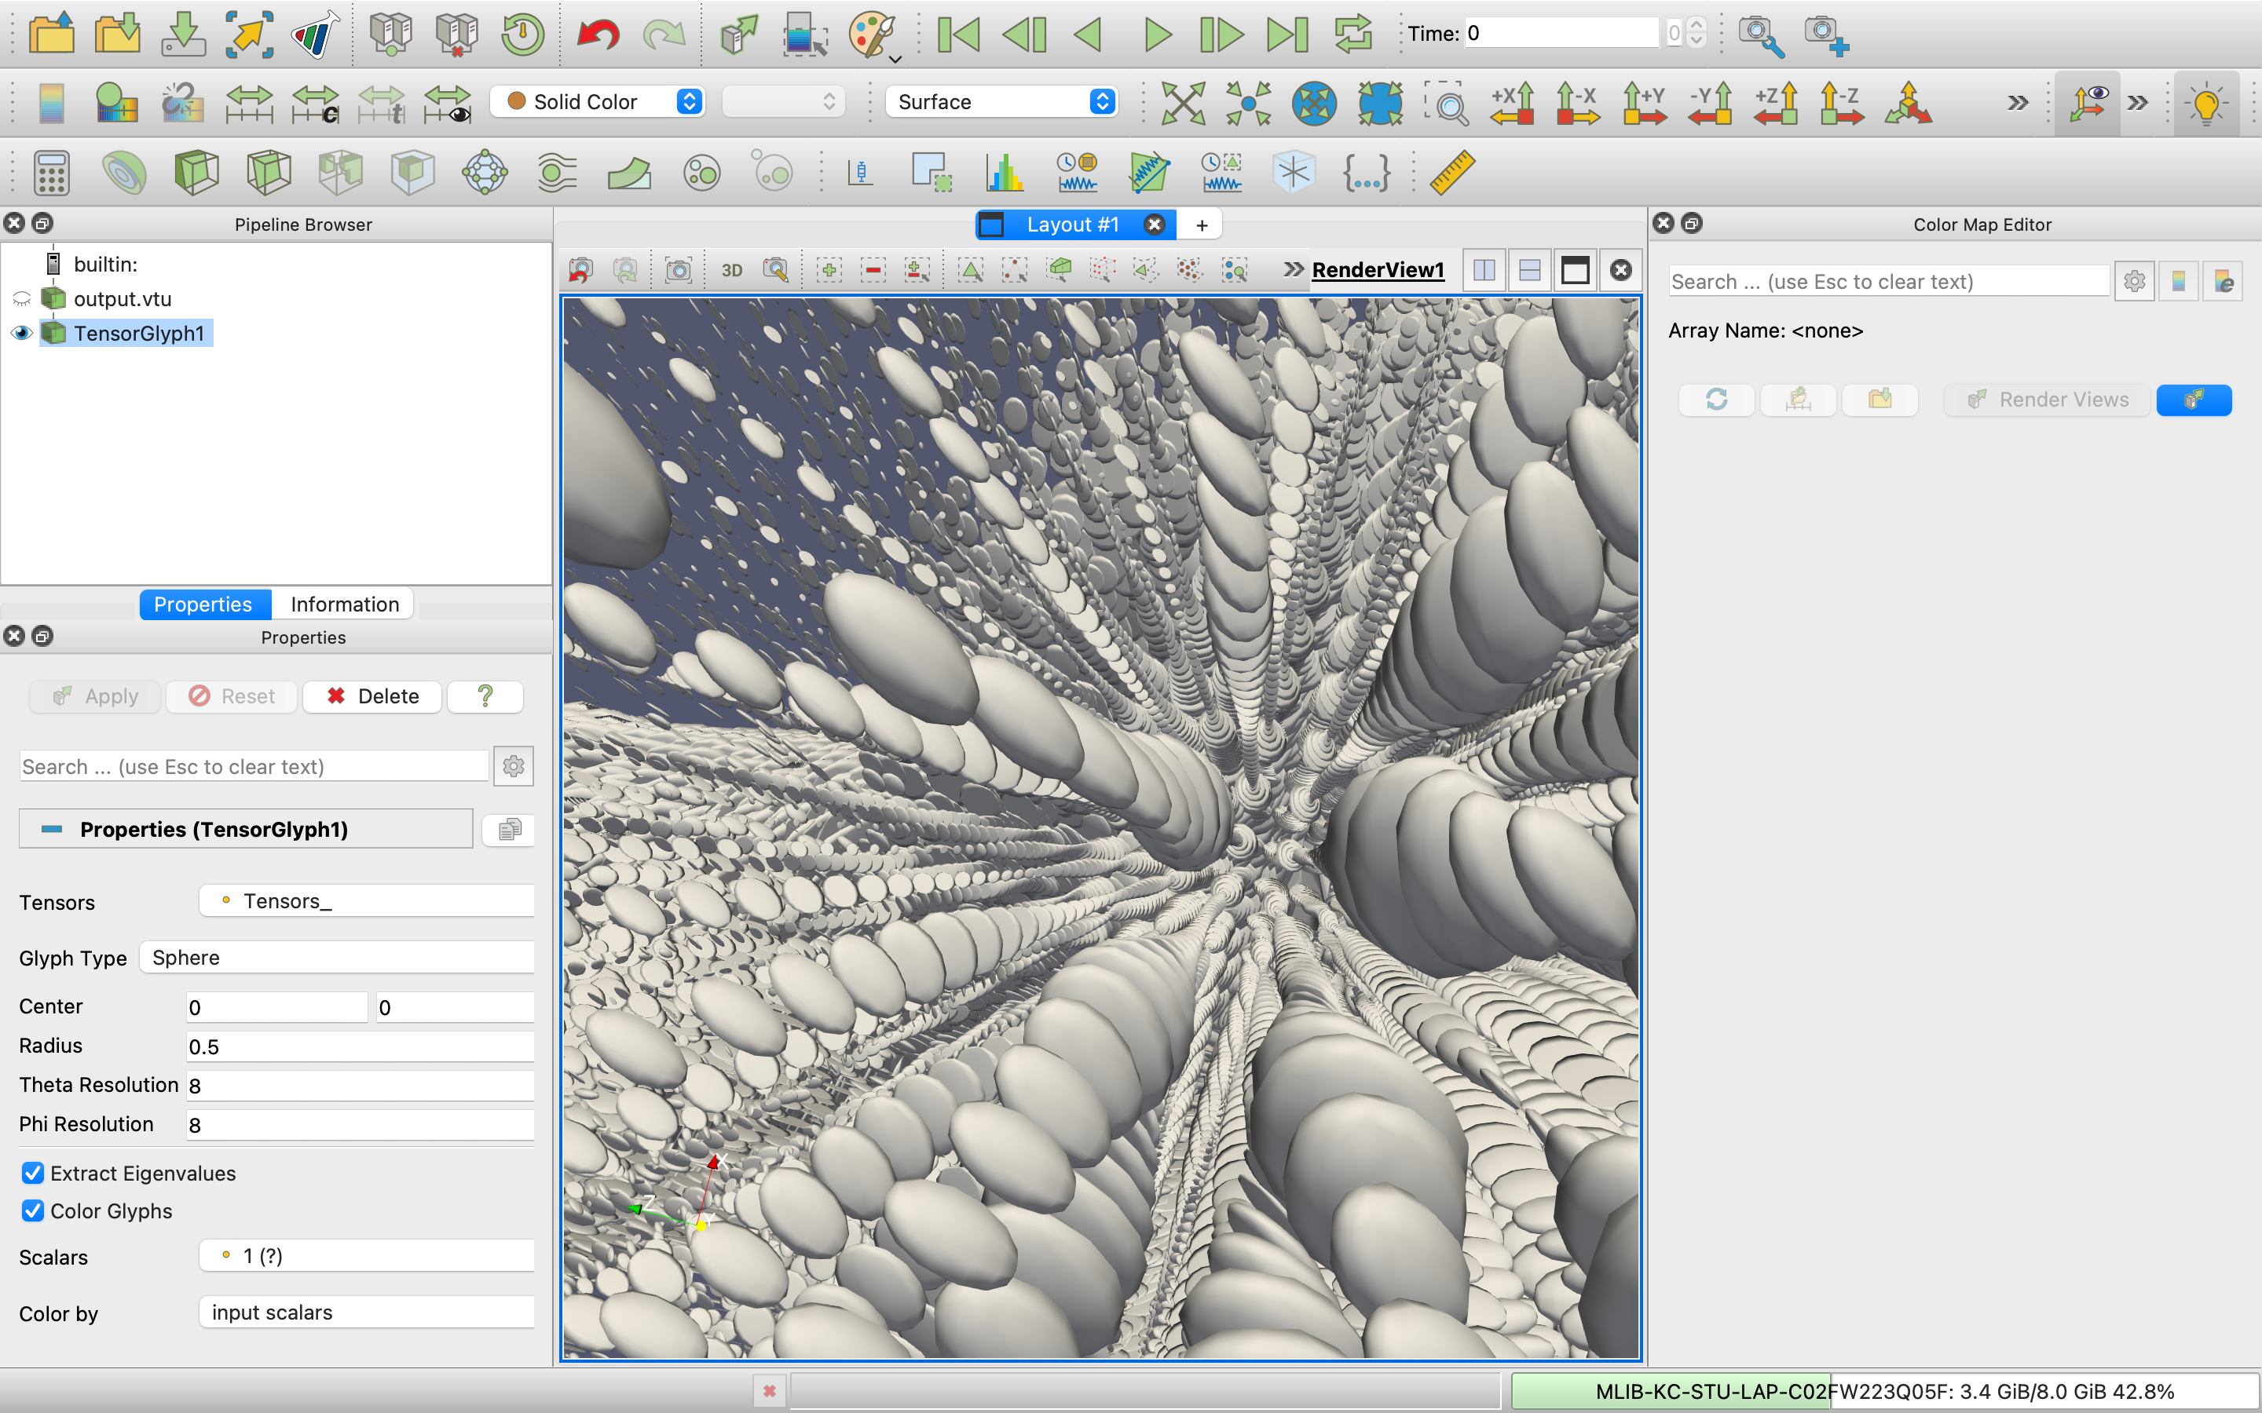
Fig 24: Sphere glyph closer view

- Box:
Below are the output images of sphere glyph with X Len. = 1, Y Len. = 1, Z Len. = 1, Center = 0.
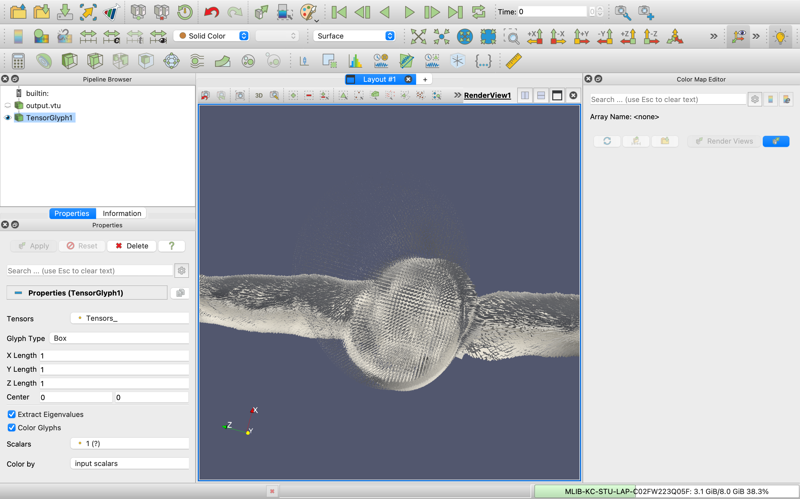
Fig 25: Box glyph from outer region

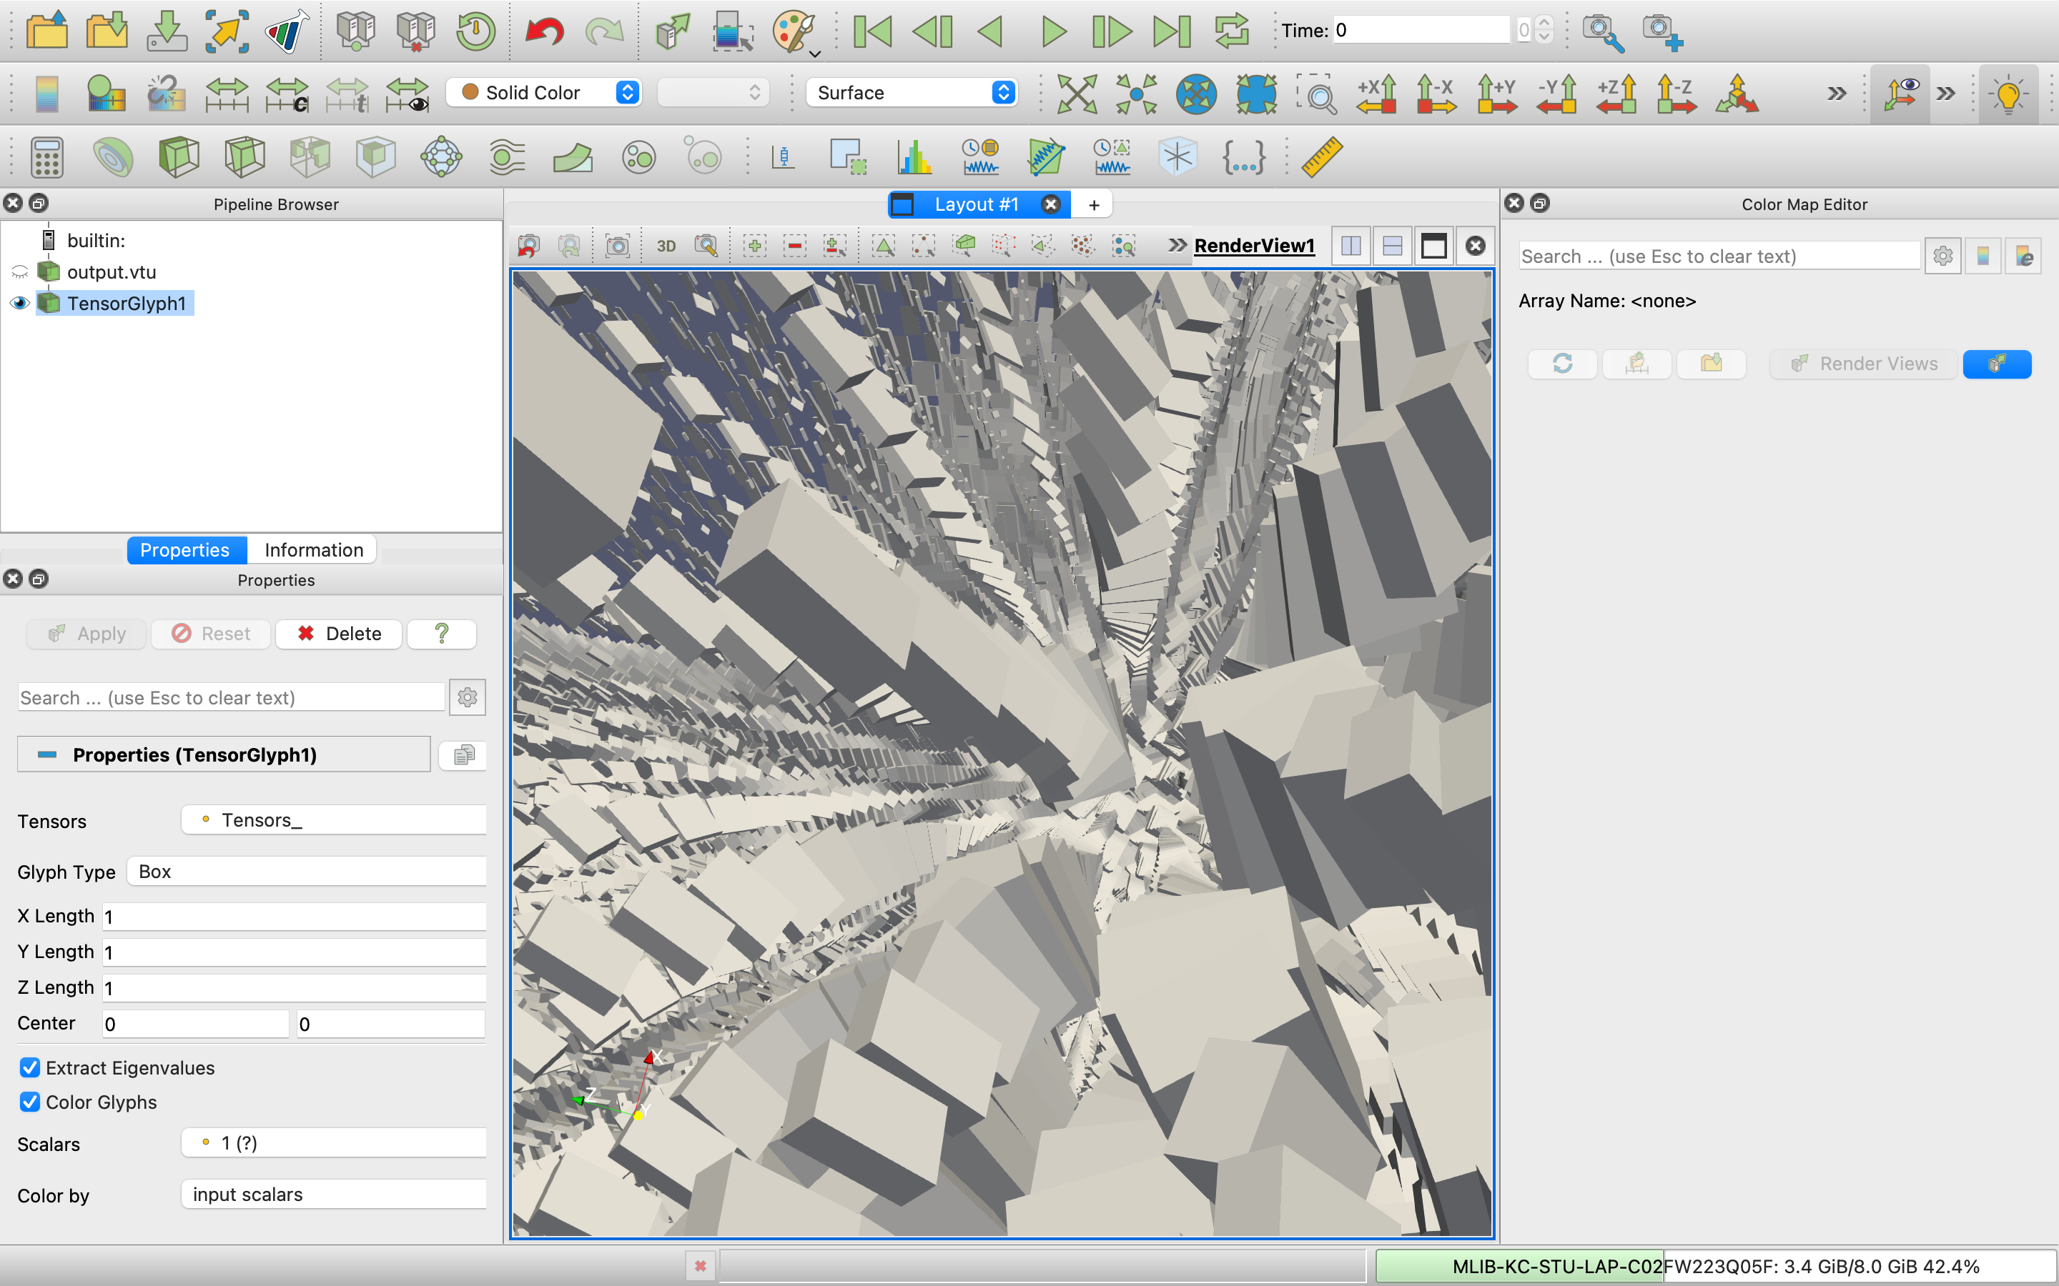
Fig 26: Box glyph closer view

- Superquadric:
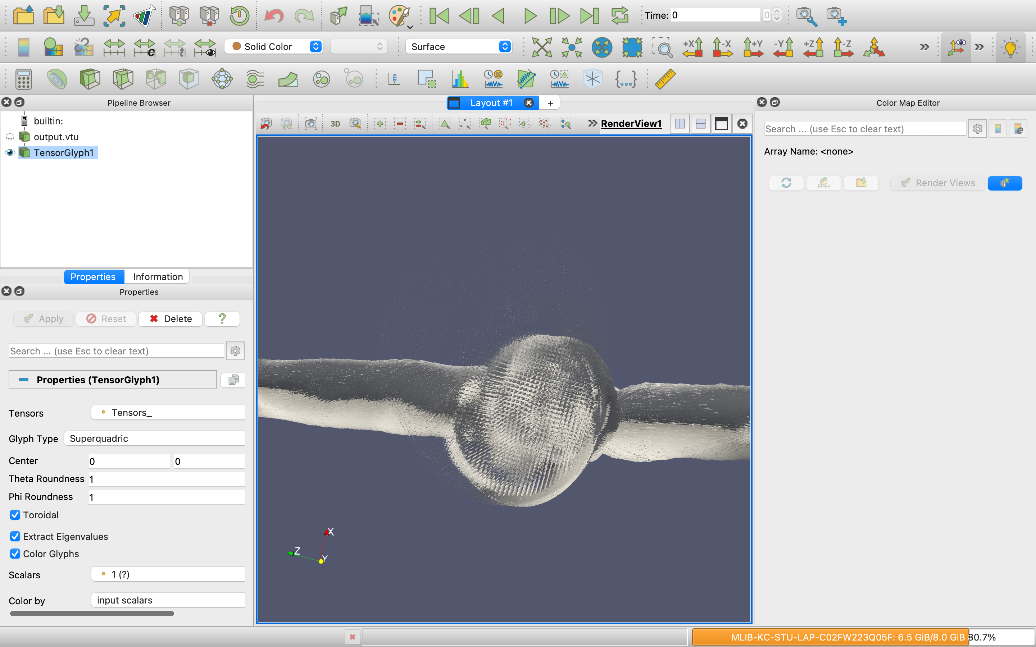
Fig 27: Superquadric from outer region
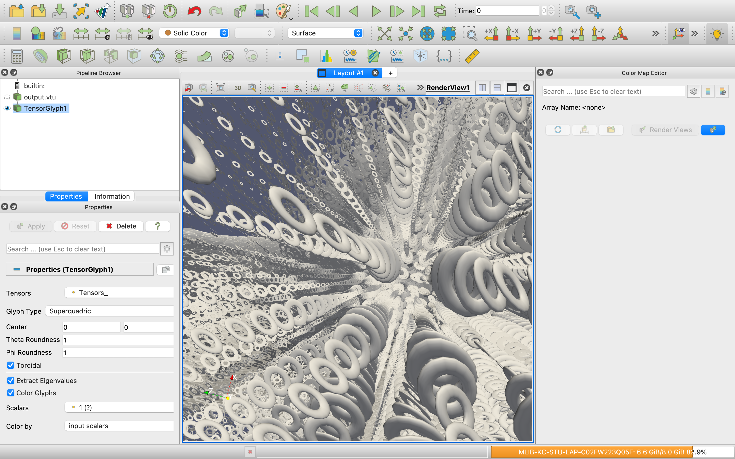
Fig 27: Superquadric glyph closer view
Which glyphs did you find the most informative for gaining insight into the tensor field data? Why?
Since the superquadric glyph is a combination of boxes and spheres, I initially expected it to be the most informative. But after looking at the images, that wasn’t really the case. I found that the box glyph, followed by the sphere glyph, actually provided more useful information about the tensor field. In both cases, the size reflects the mean diffusion, while the orientation indicates the direction of diffusion.

Part 5:
I have selected “J. Kniss, S. Premoze, M. Ikits, A. Lefohn, C. Hansen, and E. Praun; Gaussian Transfer Functions for Multi-Field Volume Visualization; In Proceedings of the 14th IEEE Visualization 2003, 2003.”
1. What is the new innovation described in the paper?
The paper introduces Gaussian Transfer Functions (GTFs) for multi-field volume rendering. Instead of using precomputed multidimensional lookup tables, which become unwieldy in size for high-dimensional data, the authors propose evaluating GTFs directly on the GPU. This allows for compact, expressive, and efficiently computable transfer functions that support analytical integration along viewing rays.
2. What did you learn by reading the paper?
I learned how Gaussian functions can serve as flexible, tunable primitives for building multi-dimensional transfer functions that classify features in volume data. The paper showed that these can be analytically integrated under certain assumptions, reducing sampling requirements and improving rendering quality. It also illustrated practical GPU-based implementation and real-world use cases such as MRI and CT data visualization.
3. What are the weaknesses in the paper?
- The paper does not deeply explore user interface challenges for managing and tuning multiple GTF primitives, which can become complex.
- While the rendering quality is well demonstrated, comparisons with other modern non-Gaussian transfer functions (e.g., neural or histogram-based methods) are missing.
- Scalability to very large datasets or many transfer function primitives is not sufficiently benchmarked in diverse contexts.
4. Are there claims made without adequate evidence?
The claim that "we rarely use more than four or five transfer function primitives at a time" feels anecdotal and would benefit from supporting evidence or a user study. Also, while performance numbers are given, real-time interactivity benchmarks under user manipulation scenarios are absent.
5. Are there weaknesses in how the authors evaluate the performance/effectiveness of their proposed technique?
Yes. While they compare GTFs to separable texture-based methods and show slice-count differences, the evaluation focuses more on technical feasibility than user perception or accuracy of feature classification. There’s also a lack of statistical performance metrics (e.g., frame rate variance, memory usage, accuracy of feature extraction across datasets).
6. Do you think the research the paper presents is useful, or is it just a curiosity?
This research is practically useful, especially in medical imaging and scientific visualization where multiple scalar fields are analyzed together. The method’s compactness, expressiveness, and GPU efficiency make it suitable for real applications — especially where lookup tables become a bottleneck.
7. What did you want to know more details about?
I would’ve liked:
- A more detailed breakdown of how parameters like the Gaussian width and center affect feature detection.
- Deeper insight into user interaction workflows with GTFs.
- More real-world deployment results, like in clinical or meteorological workflows.
8. Does the paper provide enough detail to allow you to implement the proposed technique yourself?
Mostly, yes. The mathematical formulations, pseudocode for GPU implementations, and integration strategies are thorough. However, implementation of the interactive interface and GTF editing workflow is not fully described, and would require additional assumptions or references.

Conclusion:
I can conclude that I’ve learned how to perform multi-field visualization, and getting hands-on experience with the Hurricane Katrina dataset made it both exciting and engaging. Once we figured out how to use the DGI Studio tool, answering the questions became quite fun. I also gained a solid understanding of diffusion MRI and how it works. Another new concept I picked up was tensor glyphs this assignment really helped me grasp them well since it included both theoretical and practical questions.

